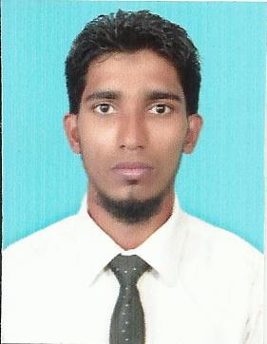**Bishrul Hafy Mohamed Farsan**

**60/7, Chairman Mawatha,**

**Massala, Beruwala.**

**Sri Lanka.**

**Phone- +94778476747 , +94711266277**

**E-Mail-** [**bhmfarsan@msn.com**](mailto:bhmfarsan@msn.com)

**PERSONEL PROFILE**

Preferred Name **:** Mohamed Farsan

Date of Birth **:** 29th June 1988

Gender **:** Male

Nationality **:** Sri Lankan

Marital Status **:** Single

School Attendance **:** 1994 – 2001 K/L Maligahena Muslim Maha Vidyalaya. Beruwala.

**:** 2002 – 2007 Al Humaisara National School. Beruwala.

**Educational Qualification**

**• G.C.E. (O/L) 2004**

**Subject Grade**

Islam A

Maths B

Business Studies & Accounting B

Arabic B

Tamil Literature B

English C

Tamil C

Social Study C

Science & Technology S

Sinhala S

**• G.C.E. (A/L) 2007**

**Subject Grade**

Economics C

Business Studies C

Accounting S

English S

**Extra-Curricular Activities**

* Enjoy all sports particularly Cricket, Swimming and Football. Love to travel and experience different cultures.

**Professional Qualifications & Training**

* DIPLOMA  IN AIRLINE  TICKETING
* Diploma in Computer Hardware and Networking
* Certificate in Networking
* Certificate in Web Designing & Development
* Basic Knowledge of Computer (MS Office, Photoshop, etc)
* Pass the MS Exam 70-410 (Installing & Configuring Windows Server 2012)

**Working Experience**

* 3 years as Reservation Executive

**# Main activities and responsibilities**

* Responsible for rooms’ bookings for guests in whole island and Maldives behalf on Company.
* Arranging vehicles for tours with drivers.
* Tour package for guests
* Handling money exchanges.
* More than 1 year as Cashier

**Extras**

* Valid Sri Lankan Driving Licence to Drive Light Vehicles

**Non Related Referees**

Mohamed Shiyam (B.A) Mohamed Ahsan

Director, Manager,

Al Inma Welfare Association Serendib Travels & Tours

(Scial Service Organization)

Beruwala.

[shiyammadani@gmail.com](mailto:shiyammadani@gmail.com) [me2ahsan@hotmail.com](mailto:me2ahsan@hotmail.com)

0094773536072 0094772220505

The above information provided by me is true and accurate to the best of my knowledge.

Signature …………………..